CSIT314 Software Development Methodologies - Group Project

Sprint 4 - US28: Delete past IDP
Interior Design Platform - Interior Designer
All diagrams were drawn in draw.io. Open "US28 Delete past IDP.drawio" in this folder to edit them - each diagram is its own page in that file. The exported images are in the "diagrams" folder.

Assumptions
- The system is the Interior Design Platform from the project specification. Sprint 4 covers the Interior Designer's past IDP stories (add, view, update, delete and search, US25 - US29) and the Customer's save IDP, search saved list and view saved list stories (US33 - US35).
- We follow B-C-E: the actor only talks to the boundary (page), the boundary only talks to the controller, and the controller works with the entity classes. There is one controller per use case.
- The boundary checks all the input (required fields, lengths, formats, e.g. not suspending your own profile) and trims spaces, then passes an entity object on. The controller just calls the entity and returns the result. The entity checks for duplicates and the database state (e.g. name already used, only Active rows are changed), then saves. In US28 there is no typed input to check: the page passes the session owner and the idpId from the URL on, the controller just calls the entity, and the entity only suspends the owner's Active past IDP.
- An IDP is an interior design project. A current IDP is one the designer is still working on (US20 - US24); a past IDP is a completed one (US25 - US29). Both are rows in the idp table with projectType Current or Past.
- Logged in as an interior designer (UC13) is the precondition. designerLoginRequired in app.py only sends someone with no session to /designer/login; the use case doesn't check the designer again (no InteriorDesignerLoginController).
- Delete is a soft delete, the same as deleting a current IDP (US23): the past IDP's status becomes Suspended and its details (and its views and saves) are kept. It then no longer shows in the past IDPs list, details, update, search or to customers.
- "Delete" on the past IDP's details (US26) loads the IDP with the controller's own loader getPastIDP(designerId, idpId) and only opens a confirmation box that names it - nothing is deleted until the designer confirms. If it isn't the designer's Active past IDP, the system shows "Past IDP not found" (HTTP 404).
- The box posts choice "delete" or "cancel". Nothing is kept in the session: the entity's check (owner, Past, Active) is enough.
- Deleted: back to the past IDPs list with "Past IDP deleted successfully". Not deleted because the IDP is no longer the designer's Active past IDP (e.g. already deleted): "Past IDP not found" (HTTP 404) - there is no second lookup. Cancel: back to the details, nothing changes. There is no restore in this story.

1. User story
Story ID | US28
User story | As an interior designer, I want to delete a past IDP so that it is no longer shown on the platform.
Actor | Interior Designer
Priority | To be agreed
Story points (estimate) | To be agreed
Acceptance criteria | 1. Given I am viewing my past IDP, when I click "Delete", then a box asks "Are you sure you want to delete <title>?" and nothing is deleted yet.  2. Given I click "Delete past IDP" in the box, then the IDP is set to Suspended (its details are kept) and I go back to my past IDPs list with "Past IDP deleted successfully".  3. Given I click "Cancel", then I go back to the details and nothing changes.  4. Given the IDP is deleted, then it is no longer in my list or search, and customers can no longer find or open it.  5. Given the IDP is missing, not mine, Current or already deleted, then I see "Past IDP not found" (HTTP 404) and nothing is deleted.
Tasks | #190 Draw Use Case Diagram and Write Use Case Description  #198 Draw BCE and Sequence Class Diagram  #206 Implement the deletion of a selected Past IDP from the database.  #250 Design Wireframe  #259 Write and Execute Test Cases

2. Use case diagram
The user story becomes one use case, UC28 Delete past IDP. The Interior Designer is the only actor. The confirmation, Cancel and not-found results are flows of this use case.
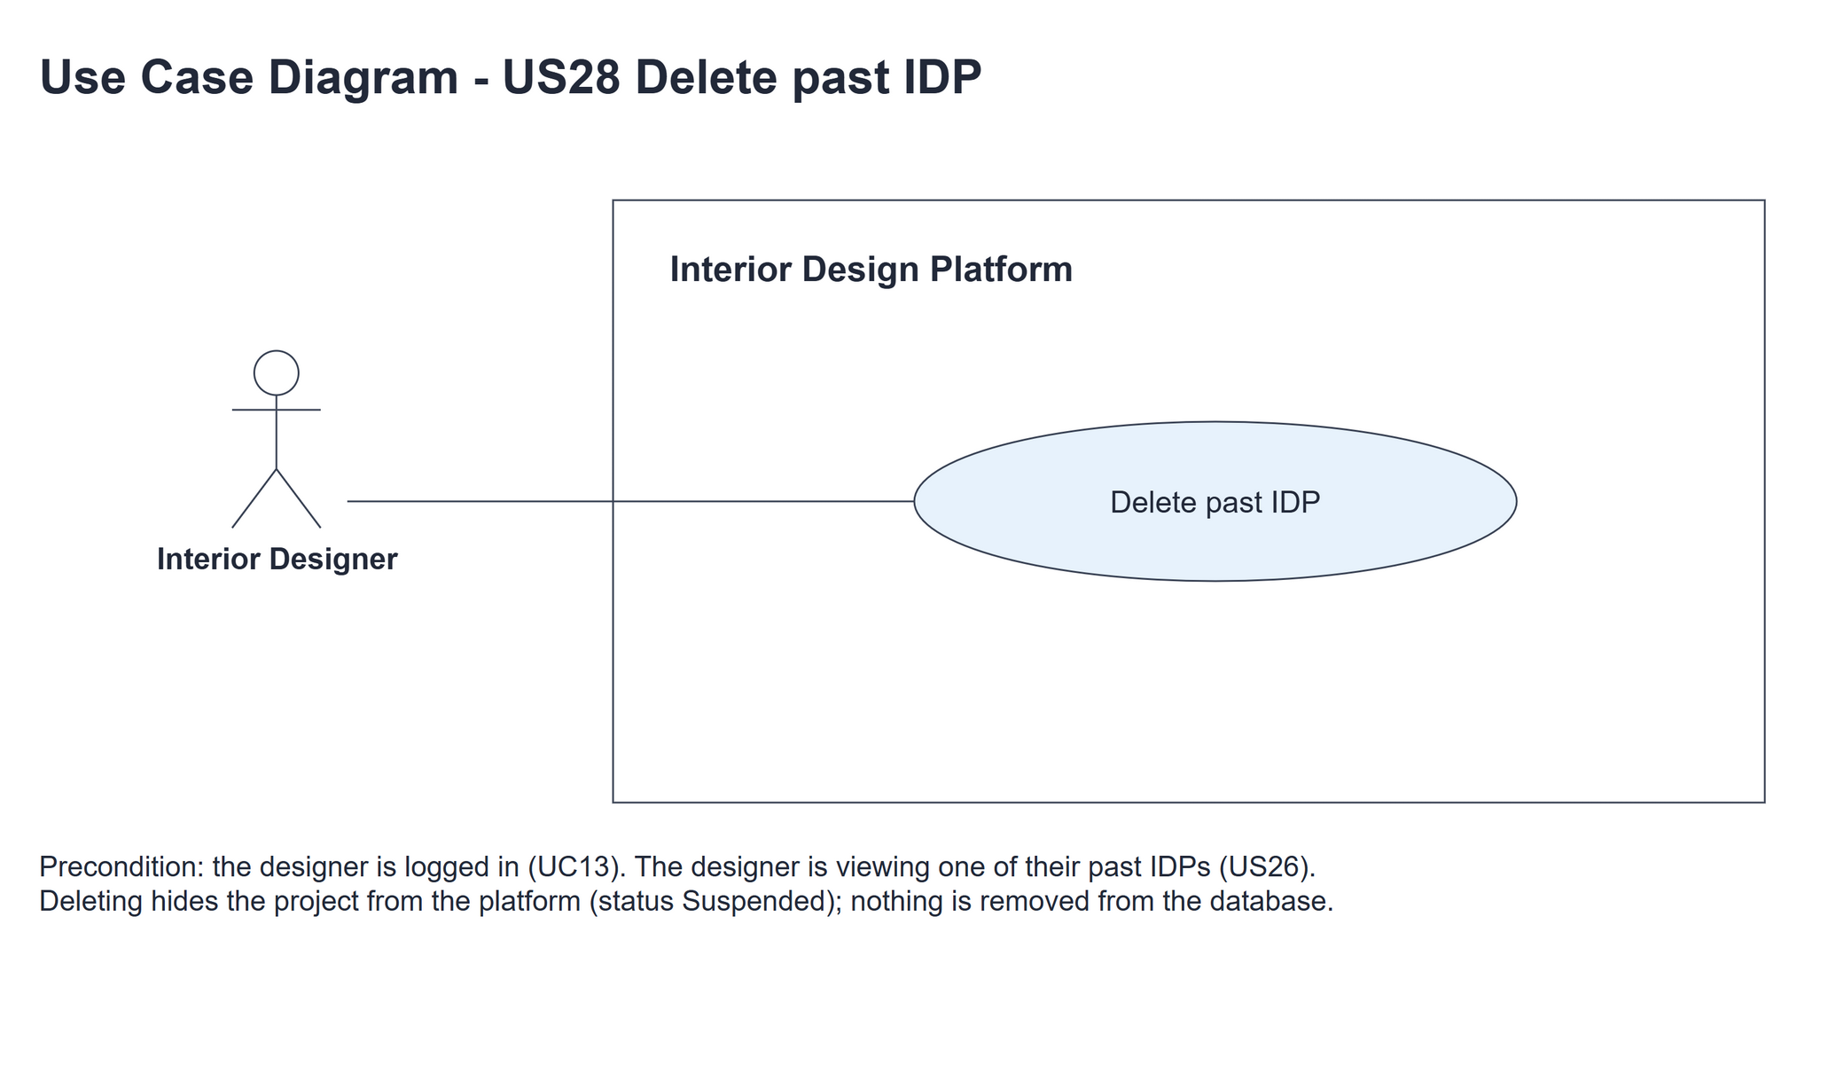
Figure 1: Use case diagram for US28 Delete past IDP

3. Use case description
Use case | UC28 Delete past IDP
Actor | Interior Designer
Brief description | The Interior Designer deletes a past IDP so it is no longer shown on the platform. The row is kept as Suspended.
User story | US28: As an interior designer, I want to delete a past IDP so that it is no longer shown on the platform.
Preconditions | The Interior Designer is logged in (UC13). designerLoginRequired in app.py only sends someone with no session to /designer/login.  The IDP is the designer's own Active past IDP (UC25).
Trigger | The Interior Designer clicks "Delete" on the past IDP's details (UC26).
Basic flow | 1. The Interior Designer clicks "Delete".  2. The system loads the designer's Active past IDP.  3. The system shows a confirmation box naming the IDP.  4. The Interior Designer clicks "Delete past IDP" in the box.  5. The system sets the IDP to Suspended if it is still the designer's Active past IDP. Its details are kept.  6. The system shows the past IDPs list with "Past IDP deleted successfully".
Alternative flows | 2a. The IDP is missing, someone else's, Current or deleted: the system shows "Past IDP not found" (HTTP 404). The use case ends.  4a. The Interior Designer clicks "Cancel": the system goes back to the details. Nothing changes.  5a. Nothing was deleted because the IDP is no longer the designer's Active past IDP (e.g. it was already deleted): the system shows "Past IDP not found" (HTTP 404). Nothing changes.
Postconditions | The past IDP row and its details are kept as Suspended; it is no longer shown on the platform. Other IDPs, categories and accounts are unchanged.

4. Wireframes
The wireframes were drawn in draw.io. They are low-fidelity: they show the layout and the flow, not the final colours. The orange numbers match the notes under each screen.

4a - Confirm delete
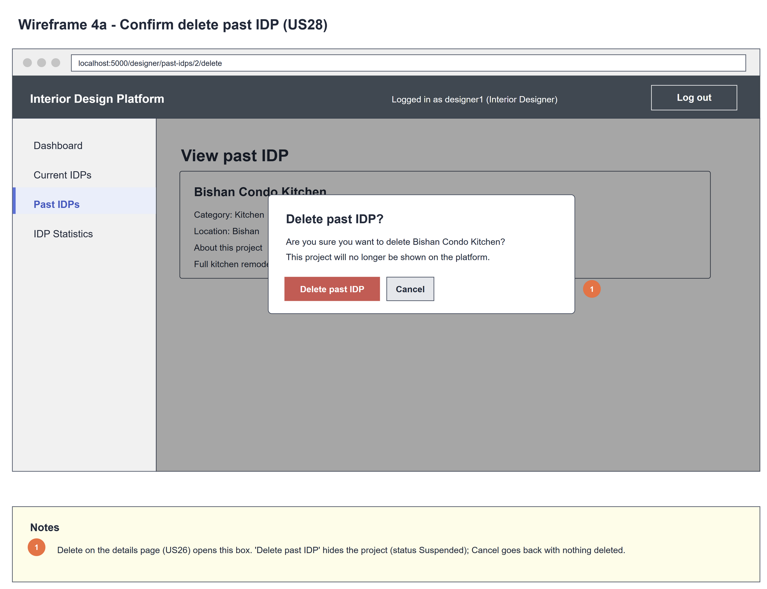
Figure 2: Wireframe 4a - Confirm delete (US28)

4b - Past IDP deleted
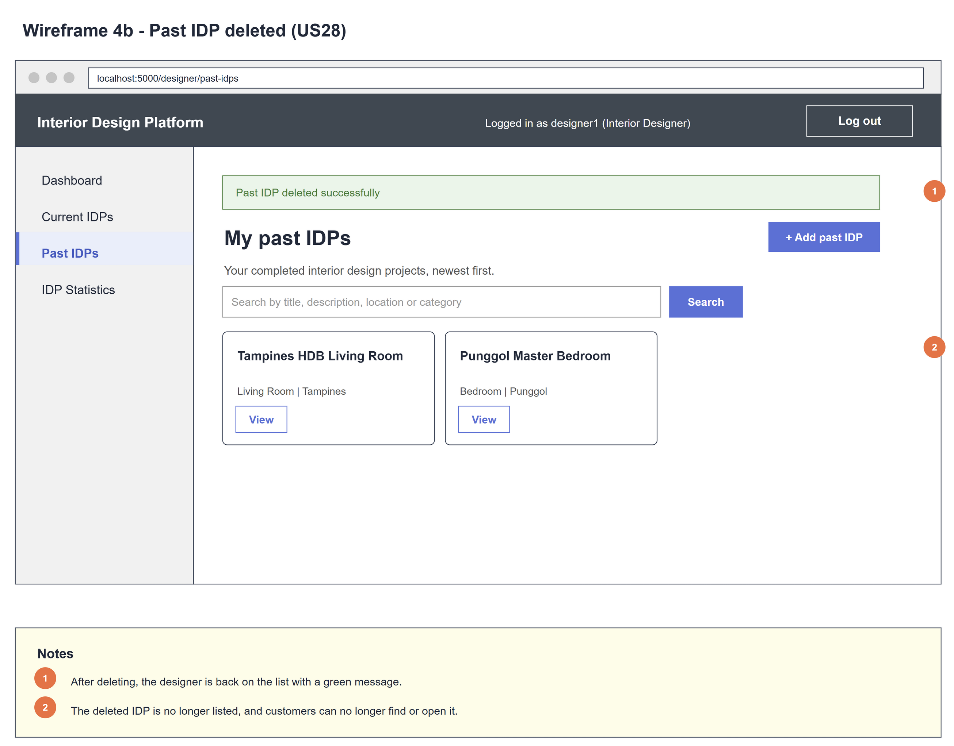
Figure 3: Wireframe 4b - Past IDP deleted (US28)

5. B-C-E class diagram
The solid line means the boundary calls the controller. The dashed line means the controller uses the entity. Only the operations needed for this use case are shown. Delete is what the designer sees; Suspended is the stored status. PastIDPListPage is the same page class as US26; these are its US28 methods.
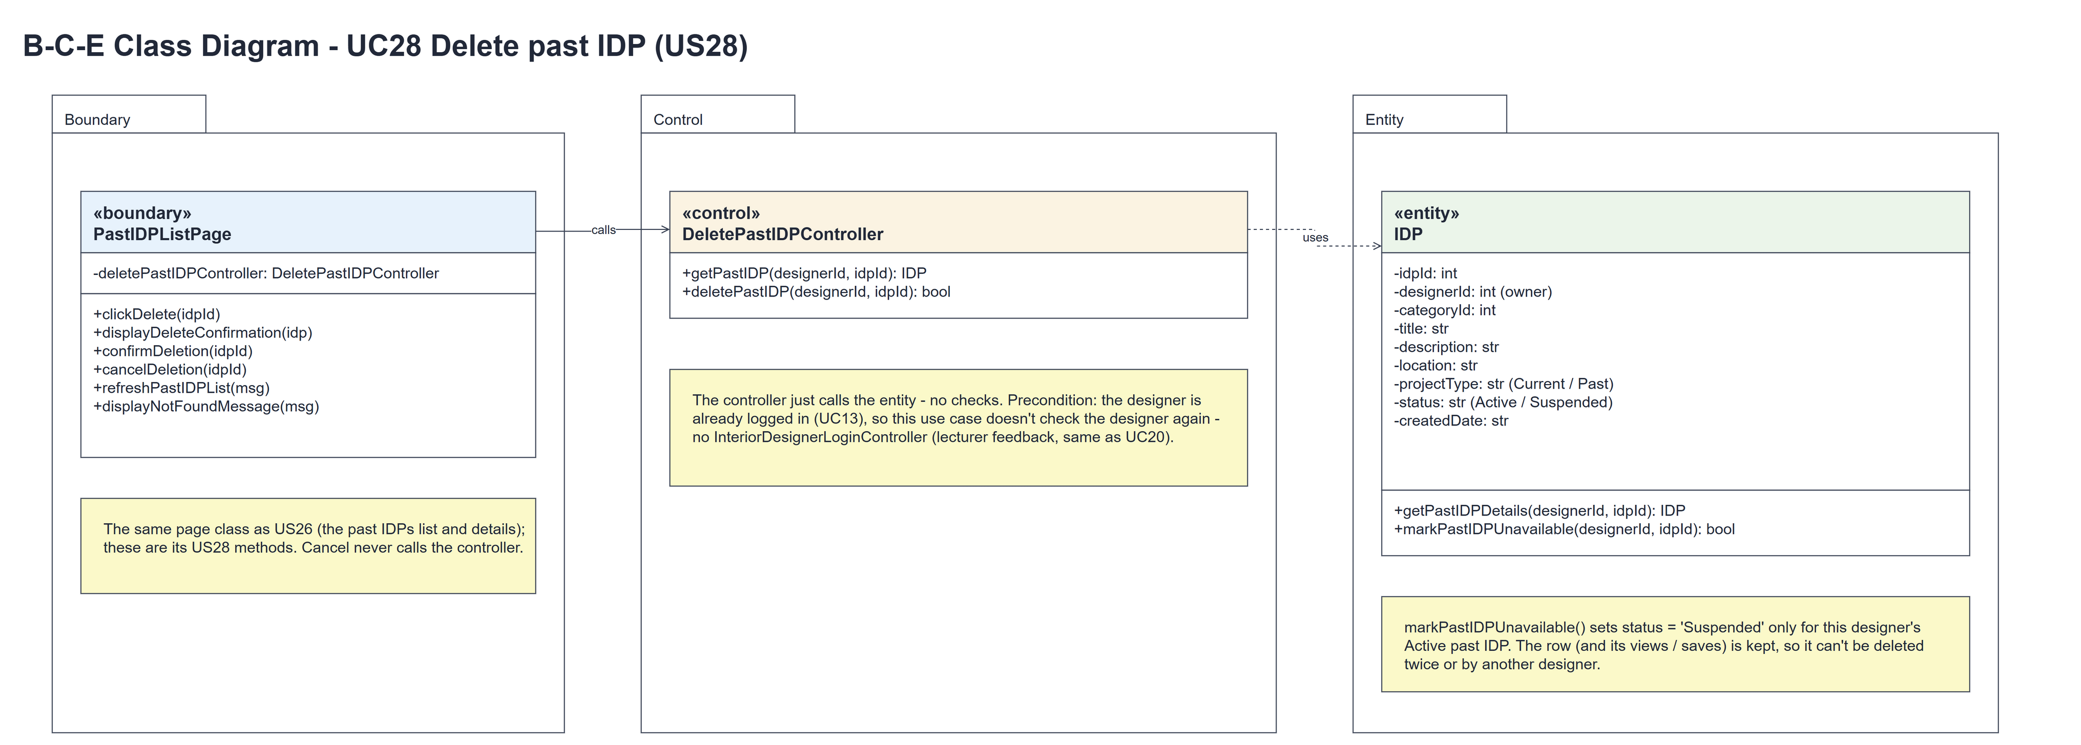
Figure 4: B-C-E class diagram for US28 Delete past IDP
Layer | Class | What it does
Boundary | PastIDPListPage | The confirmation box. clickDelete(idpId) loads the IDP with getPastIDP() and shows displayDeleteConfirmation(idp) or displayNotFoundMessage(MSG_NOT_FOUND) (HTTP 404). Choice "delete" calls confirmDeletion(idpId), which passes the session owner and idpId to the controller and shows refreshPastIDPList(MSG_DELETED) or displayNotFoundMessage(MSG_NOT_FOUND); choice "cancel" calls cancelDeletion(idpId), which goes back to the details.
Control | DeletePastIDPController | Controller for UC28. getPastIDP(designerId, idpId) is its own loader for the box and deletePastIDP(designerId, idpId) just calls IDP.markPastIDPUnavailable() and returns the result - no checks.
Entity | IDP | The only entity. getPastIDPDetails() returns the owner's Active past IDP, or None. markPastIDPUnavailable(designerId, idpId) sets status = 'Suspended' only for that row; the details are kept; no row changed -> False.

6. Sequence diagram
The sequence diagram follows UC28. Clicking "Delete" calls the controller's own loader getPastIDP(designerId, idpId), which makes one call to IDP.getPastIDPDetails() (steps 1-2); the first alt shows the confirmation box (step 3) or the not-found page (2a). The second alt picks the branch from the button: "Delete past IDP" calls confirmDeletion(idpId) and deletePastIDP(designerId, idpId), which makes one call to IDP.markPastIDPUnavailable() (steps 4-5), and the inner alt shows the list with "Past IDP deleted successfully" (step 6) or, when nothing was deleted, displayNotFoundMessage(MSG_NOT_FOUND) - HTTP 404 (5a); "Cancel" goes back to the details (4a). There is no second lookup - the entity's check is enough.
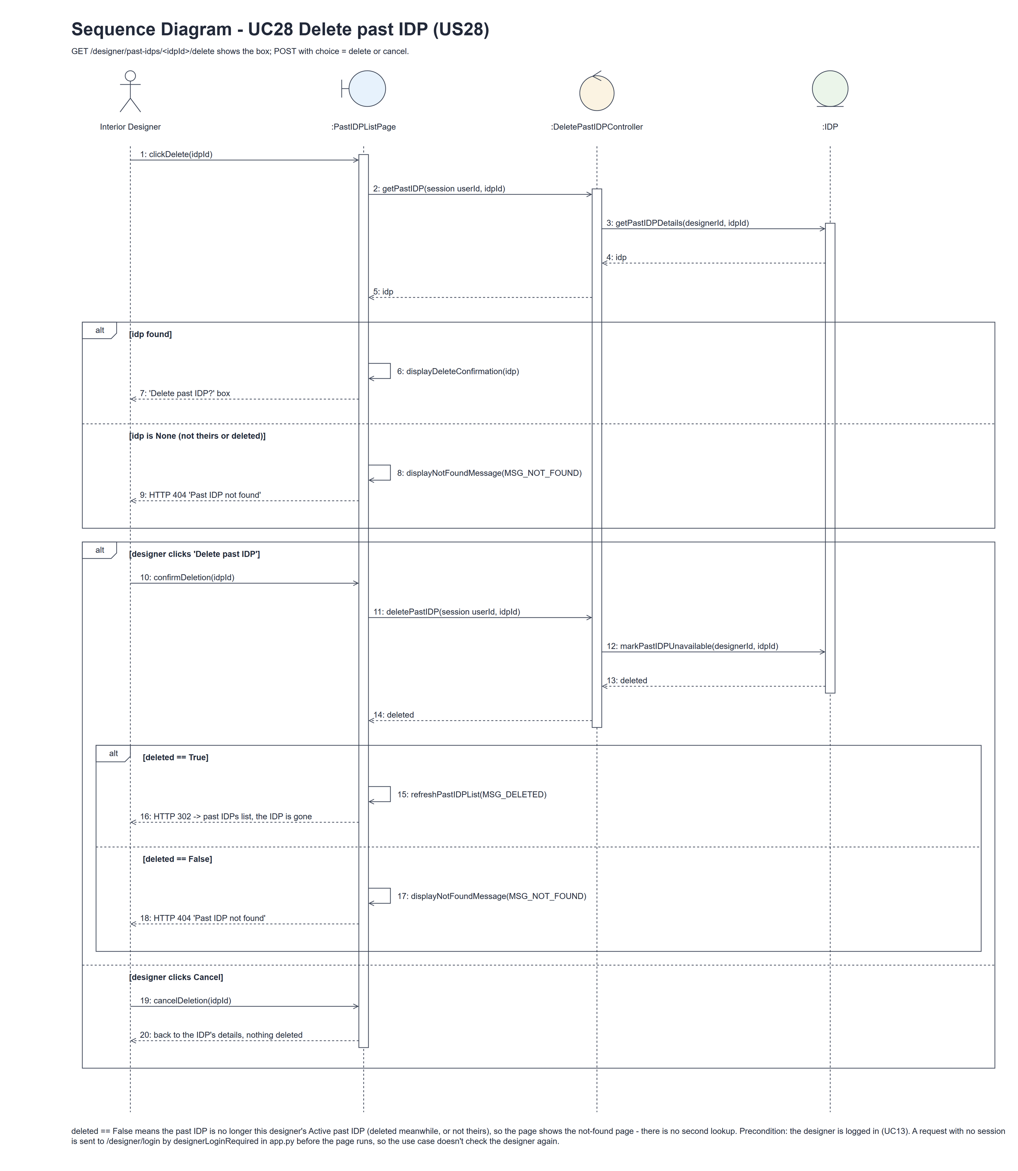
Figure 5: Sequence diagram for UC28 Delete past IDP

7. Test cases
Test data used below (the same as tests/test_us28_deletePastIDP.py, which reuses the US25 helpers): designer accounts designer37 (A) and designer28b (B) / Design@123, made with UC8. IDP category Kitchen (Active). A owns the past IDP "Completed Kitchen" and a current IDP "Current One"; B owns a past IDP. The team's first Sprint 4 test used the past IDP "Modern 4-Room HDB Resale Transformation".

7a. System test cases (black box)
Equivalence partitioning and boundary value analysis were used to pick the test data. Fill in "Actual result" and "Pass/Fail" after running each test.
Test ID | Scenario | Prerequisites | Test steps | Test data | Expected result | Actual result | Pass / Fail
TC28.1 | Open the confirmation box | Logged in as A. | 1. Open the details / 2. Click "Delete" | Completed Kitchen | "Delete past IDP?" with "Are you sure you want to delete Completed Kitchen?", Delete past IDP and Cancel. Nothing deleted.
TC28.2 | Delete the past IDP | The box is open. | 1. Click "Delete past IDP" in the box | Modern 4-Room HDB Resale Transformation | "Past IDP deleted successfully" on the past IDPs list; the IDP is gone from the list; the row is kept as Suspended.
TC28.3 | Cancel | The box is open. | 1. Click "Cancel" | - | Back on the details; nothing changed.
TC28.4 | Old links | TC28.2 done. | 1. Open the old details, update and delete URLs | Deleted idpId | HTTP 404 "Past IDP not found"; no details.
TC28.5 | IDP not available | Logged in as A. | 1. Open / post the delete URL of each IDP | B's IDP, A's current IDP, 999999 | HTTP 404 "Past IDP not found"; nothing deleted.
TC28.6 | Box sent twice | TC28.2 done. | 1. Press Back / 2. Click "Delete past IDP" again | - | HTTP 404 "Past IDP not found"; nothing more is deleted.
TC28.7 | Customers no longer see it | TC28.2 done. | 1. Log in as a customer / 2. Search for it (UC31) | "Modern" | The deleted past IDP is not listed.
TC28.8 | Not logged in | Not logged in. | 1. Post choice=delete to the delete URL | - | Sent to the designer login page; nothing deleted.

7b. Unit test cases (for TDD)
These are written before the code (test-driven development) and run automatically in the CI pipeline. They cover normal inputs, abnormal inputs and boundary values. Each one matches a test function in tests/test_us28_deletePastIDP.py (UT28.1 is test_ut28_1_...). "Pass" is from the pytest run on 10 November 2026.
Test ID | Class and method | Input / setup | Expected output | Type | Pass / Fail
UT28.1 | IDP.markPastIDPUnavailable(designerId, idpId) | A, A's past IDP | True; status Suspended; the row is kept; no longer listed | Normal | Pass
UT28.2 | IDP.markPastIDPUnavailable() | B for A's IDP; A's current IDP; the same delete twice | False; False; True then False | Abnormal | Pass
UT28.3 | DeletePastIDPController.getPastIDP() and deletePastIDP() | A's past IDP | Returns it; True; then getPastIDP() returns None | Normal | Pass
UT28.4 | PastIDPListPage.clickDelete() | GET the delete URL of A's IDP | "Delete past IDP?" box with the title; nothing deleted yet | Normal | Pass
UT28.5 | PastIDPListPage.confirmDeletion() | POST choice=delete | "Past IDP deleted successfully" on "My past IDPs"; status Suspended | Normal | Pass
UT28.6 | PastIDPListPage.cancelDeletion() | POST choice=cancel | Redirect to the details; the IDP stays Active | Normal | Pass
UT28.7 | Delete GET and POST | B's past IDP | GET: HTTP 404. POST choice=delete: HTTP 404 "Past IDP not found"; nothing deleted | Abnormal | Pass
UT28.8 | designerLoginRequired (app.py) | POST choice=delete, not logged in | Redirects to /designer/login | Abnormal | Pass
UT28.9 | PastIDPListPage.confirmDeletion() | deletePastIDP() returns False (A's IDP already deleted, POST choice=delete again) | displayNotFoundMessage(MSG_NOT_FOUND): HTTP 404 "Past IDP not found"; getPastIDP() is not called a second time and there is no other error message | Abnormal | Pass

